**Quilters Unlimited E-Mail Directions**

For the purpose of this tutorial, I will be using a now-non-existent “programs@quilttallahassee.com” account.

Your exact e-mail address and password will be provided to you separately.

-------------

Open your internet browser and enter the following URL>

<http://webmail.quilttallahassee.com/default.html>

The page should look like this:

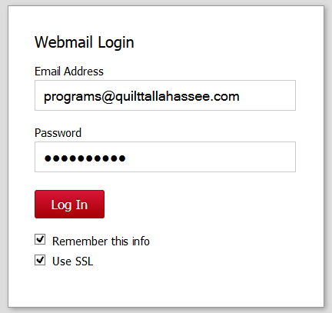

When you start out, the “Remember this info” box probably won’t be checked. If you are using a computer that only you will access, it is generally safe to check this, as it will make it easier to log in the next time.

When you start out, the “Use SSL” may or may not be checked. Do check it.

MAIN SCREEN

Once you Log-In, this is what the main screen will look like. Because this is such a tiny image, I’ll be showing close-ups to various functions.

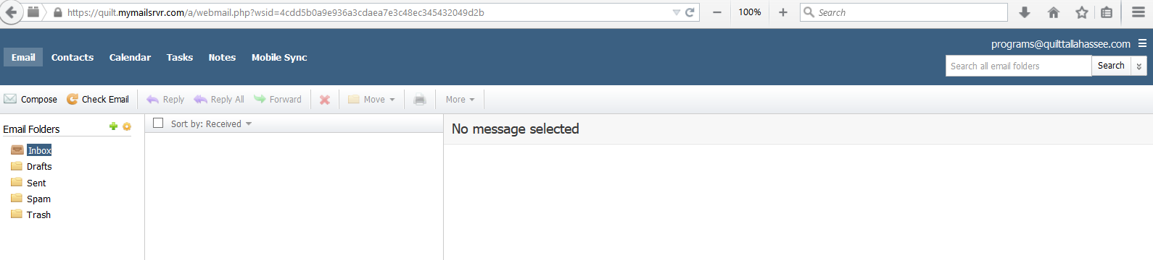

This initial screen is the **E-Mail** screen. This page should be pretty intuitive.

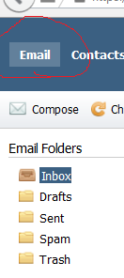

If you want to create an e-mail, click “Compose”. The system will try to auto-fill in the name as you type if the name is that of a Guild Member that we have listed in Contacts (more on Contacts below). Or click on the To: button and see the whole list of names.

If you need to save your draft e-mail mid-work, click on “Save As Draft”

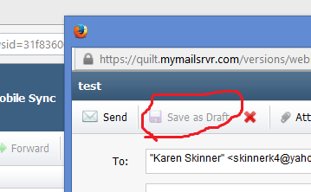

When you are ready to resume work on the Draft, click on the Drafts folder, click on the draft you want to open, and then click on “Resume Draft”.

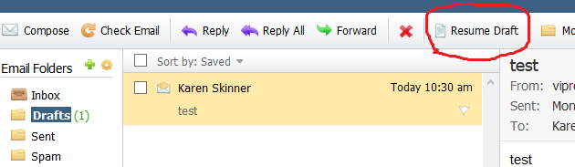

If you have an e-mail you want to **delete**, click the box next to it then the red X. You’ll need to delete your SPAM folder frequently, as we get a lot of SPAM. Likewise, you’ll need to empty your TRASH folder. There is another way to empty a whole folder – more on that below.

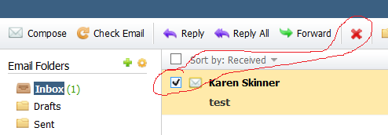

------------

I haven’t used the Calendar, Tasks, Notes functions in this system, so I can’t tell you about them.

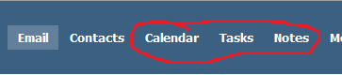

We do NOT have use of the Mobile Sync function.

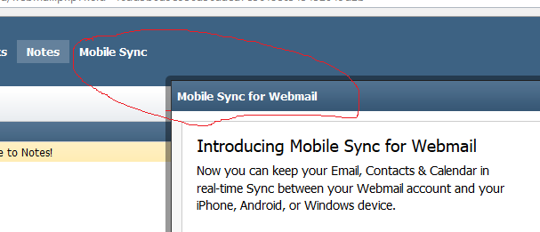

------------------------------------------

You can **create folders** by clicking on the **green +**. I just made the one called “Scrambled Eggs”. Then you can move e-mails into that folder.

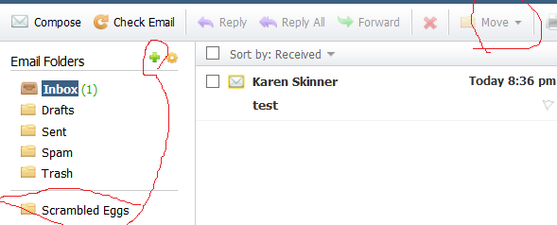

To empty a whole folder (otherwise known as “Purge” it, click on the **tan cog** next to the green +. It should look something like this (I cut out the middle, so it would fit on this page). To empty the “Scrambled Eggs” Folder, you click on the box to the left of the folder name, then click on “Purge”.

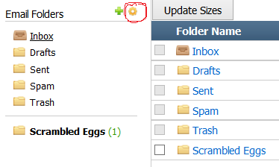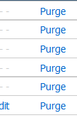

CONTACTS

When you click on the Contacts Function, it will look like this:

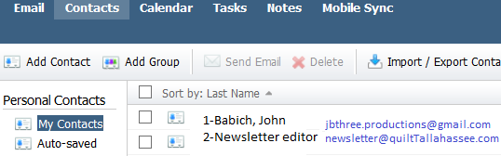

I only cut/paste part of a few names. We try to keep the list updated with all of the current Guild Members, but the list gets “stale” as we add new members, and we have to update the list once in a while. The two names showing above are ones I added to my QU account, and recommend you do likewise (see further below about adding contacts). John Babich is our System Administrator/Webmaster, and the other is (obviously) the address for the Newsletter.

-------------------------

You can add your own contacts, but I strongly recommend that you keep a backup in a separate file (not on this system) of the name and e-mail address of your new contact. That is because we’ve had some problems in the past whereby when we uploaded the updated list, everything on it before was replaced (wiped out) by the new list. We are trying to improve that system, but it is very, very complicated. Consider yourself warned.

To add a contact, click on the Add Contact (duh) button, then fill out the form with at least the first name, last name and e-mail address, you can add other details, but follow the advice above re backups. [Ignore the 1TunaFish contact below for the moment. It will be explained later.]

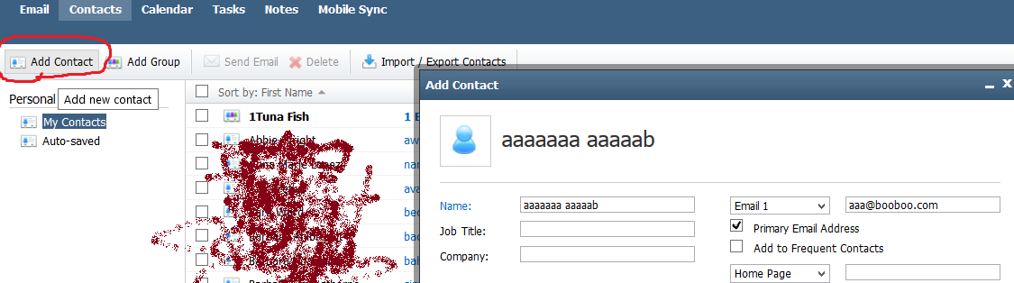

(Pardon the attempt to camouflage names and provide some privacy)

And here is how it shows in the list.

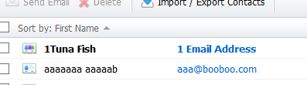

-------------------------------

DO NOT mess with the Import/Export function – the System Administrator handles these actions.

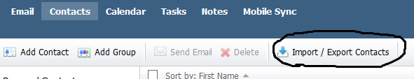

The contacts list only displays 100 names at a time, so you have to toggle between the first half of the list and the second half if you are looking for a particular name (although you can use the Search function on the upper right hand side of the screen). To toggle, use the arrows shown below.



-----------------------

You can add **Groups** (sometimes called Distribution lists). This is a very useful function. I recommend you set one up for the Steering Committee, and one for any members helping your Committee.

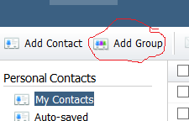

To create a group, once you’ve clicked on “Add Group”, this screen will pop up. You’ll need to type in a group name – for this example, I used “1Tuna Fish” – the reason I have 1 at the beginning of the name is that numbers precede letters in the contact listings, making it easy to find.

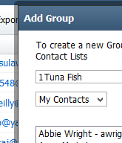

To add a member to this group, I click on a person’s name in the box on the left, then the arrow between the left and right boxes. The person’s name will then appear in the Group box.

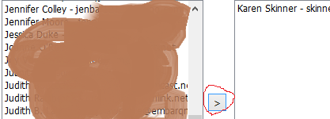

Make sure you click the Save button when you’re done.

And here is my new group>

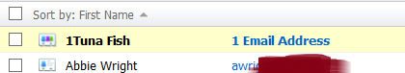

SETTINGS

There are some settings you’ll want to take advantage of. The settings choices and Log-Off are on the right side of the screen, adjacent to your account name.

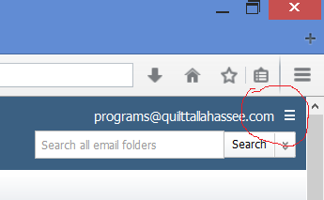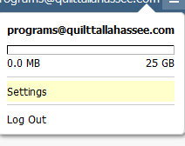

Once you click on Settings, You will open up into the **General Settings** section and it will look like this>

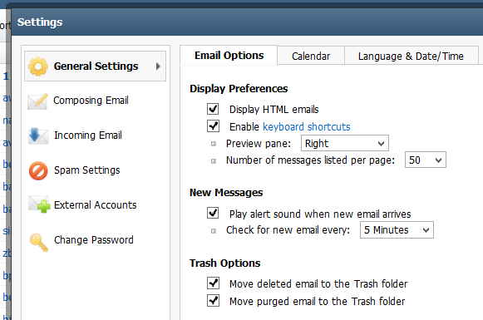

I recommend you DO NOT make any changes to the General Settings.

---------------

In the **Composing E-mail** section, I’d suggest you leave the settings in the first (“Composing”) tab alone. It looks like this>

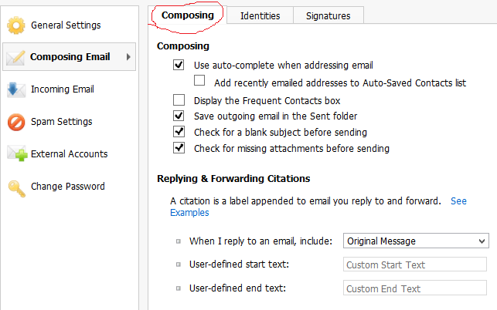

The Identities tab should be automatically filled out with your account name. Don’t tinker with this.

The Signatures Tab, this is where you can add a signature block to ad onto the bottom of your e-mails. To do this, click on the “Add Signature Button” [circled in Red; see further below about the part circled in Green]].

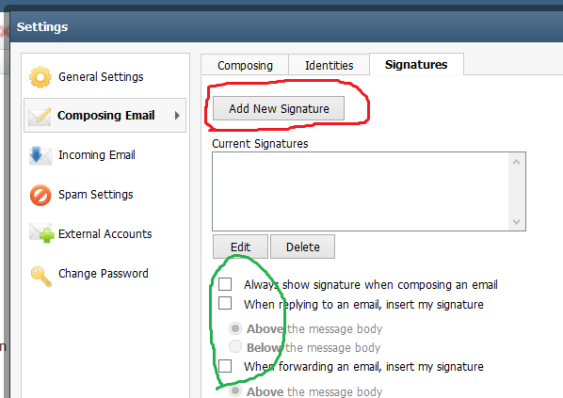

Once the New Signature Tab opens, give the signature a name – you can have multiple signature blocks, so you need to be able to choose which one. Personally, I think one is plenty for QU persons. See the example below for a design. Do click on SAVE when you are satisfied with your signature block.

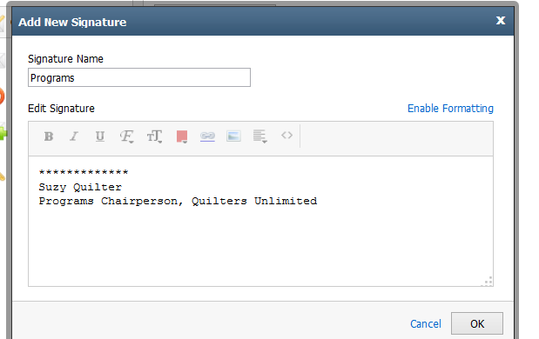

This will close out to the main Signature info Page, and you need to click Save to actually have it function. I’ll show you how it can work in an e-mail further below.

Going back up to the Green circled choices, the following is my preferred mode of use of the signature block. This particular setting allows me to choose when to use the signature block when composing an e-mail AND inserts the signature block below the text. Do as you like on above/below. I don’t use the “always show signature” because it can be a bit “stuffy” for a short note, and it gets cumbersome. However, the signature block, when coupled with your e-mail address, adds formality to your e-correspondence. As far as adding it “when forwarding an e-mail”, that’s up to you.

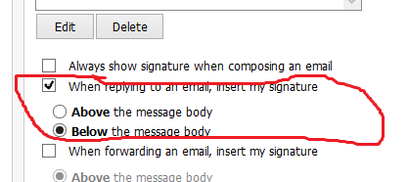

To see in action, look to the bottom of the e-mail you are composing for this box:

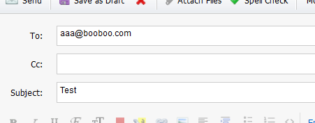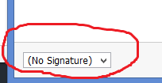

Click on the arrow next to “(No Signature)”, and you’ll see the word “Programs”, which is what I named the signature block. Click on that.

The system auto-fills in the signature that was designed above:

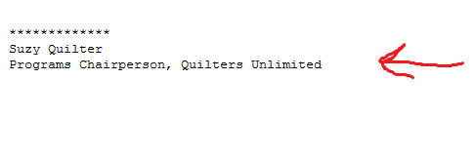

-------------

The next two Settings functions are SPAM and External Accounts. DO NOT TOUCH.

-------------

The last Setting function is “Change Passwords”. It looks like this, and is self-explanatory.

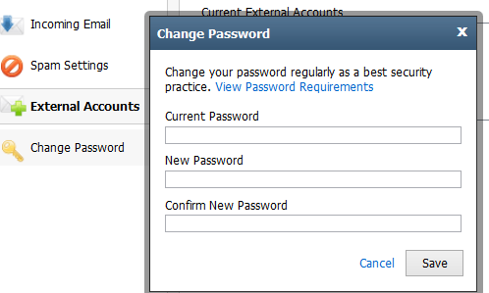

LOST PASSWORDS

If you lose or forget your password, you will need to contact the QU Website’s System Administrator. You can send an e-mail from a personal account to [webmaster@quilttallahassee.com](mailto:webmaster@quilttallahassee.com) [or jbthree.productions@gmail.com], or call John Babich at 850-321-7621.