Making Hanging Ribbons for QU24SHOW: KALEIDOSCOPE OF COLOR

The purpose of these ribbons is to suspend skirt hangers so that quilts can be hung below other quilts from pipes that are 8 feet or 10 feet high. 11 spools of ribbon were purchased from PaperMart.com. Each spool contained approximately 100 yards of 1½-inch-wide ribbon

Step 1. Cut a ribbon to 12½ feet long or 16½ feet long. (*For the 2024 show, 7 of 11 spools of ribbon were cut 12½ feet, yielding 24 lengths per spool. The other 4 were cut 16½ feet yielding 18 lengths per spool*.)

Step 2. **Crease/pin** the two diagonal folds shown below, measuring to leave **1⅝ inches open** between the folded areas. **Stitch** on the double thickness near the edges as shown.

Step 3. **Fold** and **crease** **the slanted sections** to form the “slot,” leaving a ½ inch “tab” beyond the fold line.

Fold line

*Note: These illustration are not to scale. The ribbon is actually 1 7/16" wide.*

*So these images are about half sized.*

*Ribbon continues*

½"

“tab”

{

Fold line

*Note: The ribbons have no right or wrong side. Color difference is for illustration only.*

“tab”

“tab”

Mark 1⅝"

Fold line

{

{

1⅝"

“STITCH”

“STITCH”

“STITCH”

Fold first

Fold second

“tab”

“tab”

Step 4. **Stitch** across the “tab” area. The slot is deliberately a tiny bit wider than the ribbon to make it easy to slide the long end through it.

NOTE: You will now see that a **slot** has been created. That slot should be open at the top and the bottom. When the ribbon is laid over the pipe, the long end of the ribbon will be slipped through the slot and pulled down to gently tighten the ribbon to the pipe.

Step 5. Fold the long end of the ribbon so that it almost touches the near end of the slot. Be sure that the ribbon does not have any twists and lies flat for its approximately six-foot (or eight-foot) length. *Note: Because there is no right or wrong side to the ribbon, it doesn’t matter which way you fold it. But I found it nice to tuck the end of the ribbon under the tab.*

Step 6. Pin just below the tab area. This keeps the ribbon doubled.

Step 7. Pin at about 25" from the near end of the slot.

Step 8. Start at the near edge of the slot next to the long part of the ribbon. Measure **28"** and draw a line. A pencil worked fine. (*Note: Your line will be about 29½" from the farther edge of the slot.*)

Step 9. Pin at about 8" and each foot after that.

Step 10. Move 6" farther than the line at 28" and draw another line. Add lines every 6" after that. (*There will be about 3" beyond the last line you draw.)*

Step 11. Sew right below the slot to secure the end of the ribbon, **checking that the slot is still open at top and bottom**. Then sew along all the drawn lines.

DONE!

**NOTE: The photo was taken to show the importance of measuring carefully and consistently when you’re drawing the lines. In order to have quilts hang level from these ribbons when they need more than one skirt hanger, the lines need to be at the same distance from the top on each ribbon.**

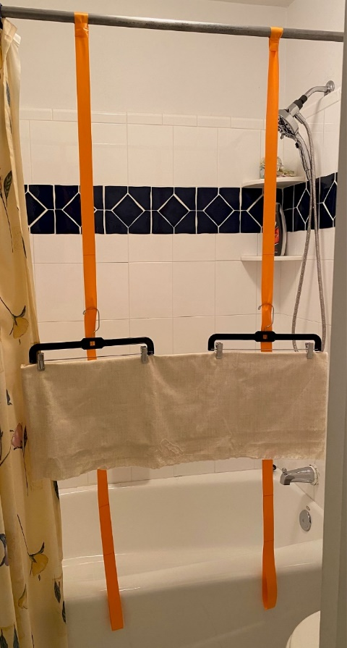

STORAGE

I stapled the spools the ribbons came on inside 10-inch cardboard cake rounds to create bigger spools. Bigger spools were needed because the folded-and-stitched ribbons with slots don’t wind as tightly as the unstitched ribbons did. I added some cardboard strips to make the center of the bigger spools as big as the edges of the original spools.

I wound the ribbons without any kind of attachment to the spools so they should be easy to pull out when hanging the quilts.