The purpose of this notebook is to serve as a guide for the role of

Web Coordinator

Although the role may seem obvious in some ways, documentation of the responsibilities will ensure consistency from year to year and promote a smooth flow of events during the meetings.
Please read the guidelines thoroughly and make note of any outdated statements for future edits.
DO NOT misplace this notebook. (Note: The Web Coordinator notebook is in the form of a digital file only. Upload it to the Media Library as a docx so that it can be downloaded by the next coordinator and edited.)
Add yourself to the list on the “Previous Chairpersons” page.
Complete the end of year report in October.
Turn this notebook in to the President no later than the October guild meeting. This notebook may be emailed to the President and the new webmaster.

Thank you for your participation in the guild!


Previous Chairpersons
For
Website Committee
2006-2007 | Topi Henderson
2007-2008 | Topi Henderson
2008-2009 | Karen Skinner
2009-2010 | Karen Skinner
2010-2011 | Heather Whitehead
2011-2014 | Karen Skinner
2015-2016 | Jessica Duke
2016 | Jessica Duke
2017 | Sue Isaac
2018 | Sue Isaac
2019 | Sue Isaac
2020 | Jessica Duke
2021 | Rachel Smith
2022 | Rachel Smith
2023 | Sue Isaac
2024 | Jennifer Darnell
2025 | Sue Isaac
2026 | Sue Isaac

Guidelines
The role of the Web Coordinator is to create and manage the information content (words and pictures) and organization of the Quilter’s Unlimited website. The person fulfilling this role will need excellent computer skills in addition to being well organized and possessing the ability to communicate well with others. Access to a computer, internet connection, and the ability to use email is required. Experience with designing or maintaining websites and/or using Wordpress (the software used to maintain the website) is a plus, but not required. Access to and the ability to use Microsoft Word and Excel are very helpful for formatting documents and forwarding information from form entries to relevant committee chairs.
The Web Coordinator attends guild and steering committee meetings to gather information pertinent to current website postings, such as program titles, meeting dates, bulletin board announcements, etc.
Although guild members are encouraged to provide updated information to the Web Coordinator, the Web Coordinator should seek out information as needed to keep the website current.
The QU newsletter should be checked for announcements to be added to the website calendar and for updates to information on the website in general, e.g., changes to the program schedule for upcoming meetings.
The Web Coordinator is part of the internet team. Other team members handle email blasts and Facebook updates.
Newsletter submissions: The Web Coordinator may want to include a reminder in the newsletter for chairpersons to check their relevant pages on the website for accuracy. Note that all submissions to the newsletter must be written exactly as they will be printed. Send newsletter items to newsletter@quilttallahassee.com.
Budget: The Treasurer tells you the current annual budget for the Web Coordinator. This is usually set equal to the cost of hosting the website. If you want to spend money beyond hosting the website, you’ll need Steering Committee permission. If you hear from our web host that the fee for hosting our website will change, that should be brought to the attention of the Treasurer. Be prepared to make a recommendation to the Treasurer to modify the budget as needed. If you do spend money outside of hosting the website, keep all receipts and accurate records and use the form at https://quilttallahassee.com/membership/forms/ on the website to request reimbursement.
Guild Property: You will not have any guild property in your possession. This notebook exists only in digital form. You may print it if you choose. When you update and post the new file, remember not to include any information that shouldn’t be public.

About the Email Address for Web Coordinator
There is an address WebCoord@QuiltTallahassee.com that can be used to perform this job if you choose.
Or you can use your personal email address. If this is your choice, just mention that members should contact you about the website at the personal address listed for you in the directory.
Even if you do want to use your personal email address, it’s good to check the guild address now and again, though it generally contains spam. The webmail access address is: https://webmail.quilttallahassee.com/a/webmail.php

Contact Melissa Raulston for password changes if locked out, or change yourself in the settings.

Frequently Asked Questions
- Do I have to attend every guild meeting to be the Web Coordinator?
You should plan on attending as many meetings as possible as you will gather information valuable to the website.

- Do I have to attend the steering committee meetings?
You should plan to attend as many steering committee meetings as possible since information valuable to the website can be obtained from the meetings.

- Do I need the approval of the steering committee before posting something new to the website?
Keep in mind that QU must be sensitive to the fact that the website is a public domain and may not want all guild business posted there. Another fact to consider is the guild’s tax status. As a non-profit group, we must be careful to not list information that could promote profit for a guild member. Use your own judgement about posting new items but communicate well with any chairperson(s) related to the topic. If in doubt, ask.

Website Administrator contact info:
Melissa Raulston
850-491-6702
Melissa@platowynne.com
[Note—the previous website administrators were Jason Babich (JB) of Site Squire, and Melissa Raulston and her son, Zac Wegmann, of PlatoWynne consulting. In 2020, the account was transferred to Site Squire.]

Website Account – Where to log in to edit the webpage:
https://quilttallahassee.com/wp-login.php

A username and password will be provided to you. The outgoing Web Coordinator should send your information to Melissa Raulston and have this information sent to you. If you have trouble logging in, contact Melissa Raulston.
Wordpress Notes & Hints
You must be logged into the site to make changes.
When you log in, you will see the dashboard. It has menu choices in the left column (more on those later). What you see to the right of that is primarily information that Melissa Raulston needs to keep our website healthy.
When you are on the dashboard, you can navigate directly to our website’s home page by clicking on “Quilt Tallahassee” on the black menu bar at the top of the page. Once on our home page, you can navigate using the website’s regular menus to find another page you want to edit. To return to the dashboard, hover over “Quilt Tallahassee” again on that
black menu bar and choose “dashboard.”
EDITING A PAGE
To edit a page while logged in, navigate to it on the website and click “edit” in the
black menu bar above the top of the page. You can also find it by choosing “Pages” on the dashboard. It has a search function. “Pages” on the dashboard is also useful for finding drafts of pages you are working on but haven’t published yet or are not visible in a regular menu.
Changing Existing Text
Changing existing text in Wordpress is very similar to editing a word processing document. Position your cursor and type, use backspace to remove words, highlight and use the delete key, etc.
Formatting existing text is also similar. When you highlight text, a menu bar will appear above the paragraph. You can change the text’s color, use italics, make it bold, etc.
While you are editing text, the three dots at top right of the page will show the menu below that will allow you to select the “Code editor” if you want to see the html. “Visual editor” returns you to normal text editing. Sometimes html formatting can be helpful, but unless you know what you’re doing, don’t erase the html ‘tags’ that the software uses to help format things (there is a beginning and ending tag, ex: <strong> XXX </strong> will give you bolded or strong emphasis text for the text between the tags).
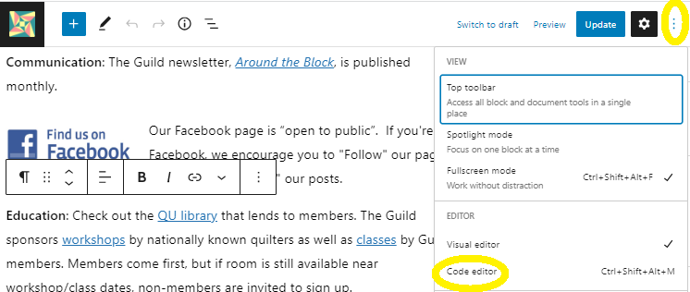

About The Block Editor
Almost all of the pages on the website are now organized in blocks. A block can be a paragraph of text. But it can also be one of many other options, such as a heading. A block used frequently on our website is “Media and Text” — it has a photo on one side and other blocks (usually headings and paragraphs) on the other.
You may still find the occasional page that uses the “classic” editor instead of blocks. You can edit them just as they are. You will also see the option to convert the text to blocks. If the existing page has involved formatting, that can be messed up by converting. If you want to make the change to blocks, it is suggested that you duplicate the page first. If changes are successful on the duplicate page, then put it on the menu and delete the old page.
Seeing And Selecting The Blocks On A Page: “List View”

Clicking on the three dashes (circled), which appear at the top of a page you are editing, will open the “list view” that will show you the structure of the blocks on the page.

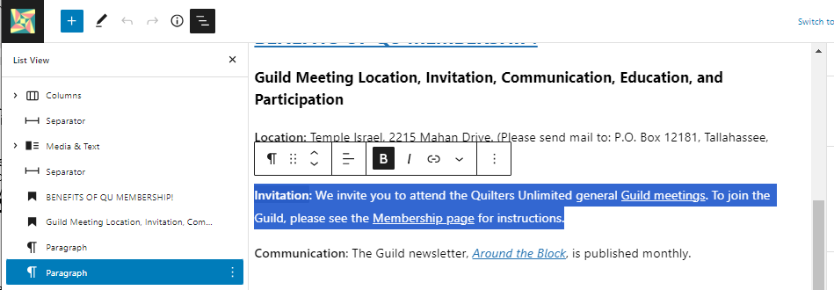
- The block you are currently working on will be highlighted on the list of blocks.
- Working in the list-view column, you can drag blocks up or down to rearrange them.
- Clicking on the > or ˅ symbols in the list will reveal or hide blocks that are subordinate to other blocks
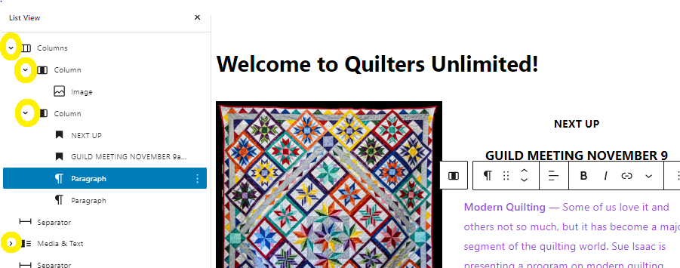
Adding Blocks
The dots open a menu that allows you to choose and insert a new block above or below the block you’re currently editing, or remove it.
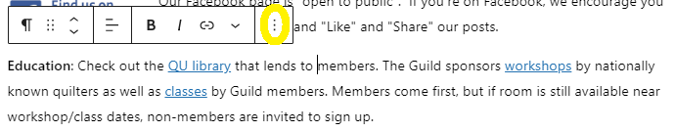
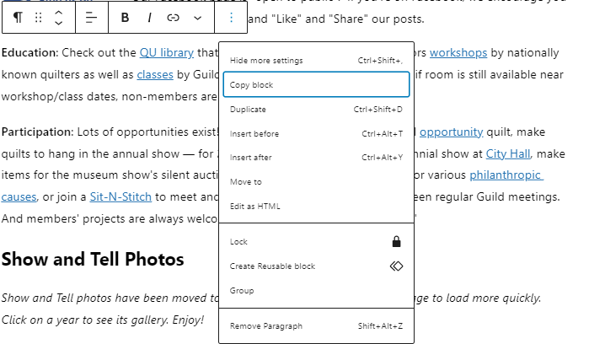
Links

Highlight text to be linked, click the circled symbol and type in (or paste in) the link.

DASHBOARD MENU ITEMS USED MOST FREQUENTLY
Posts (= the bulletin board)
Posts are the “bulletin board” part of the front page of the website. The newsletter link is always posted here. Recent practice is that the newsletter editor sends the newsletter to Melissa Raulston, who posts it on the bulletin board. If that changes, you can upload it as a file and put a link to it on the bulletin board.
Announcements can also be posted here, though in practice putting them in the newsletter is usually a better way of getting attention.
To be seen on the bulletin board, a post must have “Bulletin Board” clicked in the Category option.
Events (= the calendar)
“All Events” has a list of every event that’s been created and not yet deleted. (This includes events in the past that no longer appear on the calendar.)
Clicking on an event in this list will allow you to edit it and allow you to “Clone to Draft,” which is useful for adding the 12 new guild meeting dates for the next year once they are known.
“Add New” — Dates, times, locations, etc. Linking to other pages on the website can be done in the content box. IMPORTANT: AN EVENT MUST HAVE A CATEGORY SELECTED. If it doesn’t it won’t appear on the calendar.
Media
See what’s in the media library — all kinds of documents (docx, pdf, etc.) and photos
Add files or photos, delete files or photos, edit information about items (e.g., photo captions), and copy URL links to items.
It is best practice when adding a file or photo to the website to add it to the media library first. This allows it to be inserted easily into multiple places on the website. On a page you are editing choose “media library” (rather than “upload”), click on the item, and click “select.”
Forms
Forms are used on our website on the “Contact Us” page and elsewhere.
The subitems under “Forms” on the dashboard menu include “Help”. This has good documentation about creating and using forms. You can also learn a lot by looking at the settings for a similar form if you are creating a new one.
Forms include notifications that send messages to the person who filled out a form and to the guild officers who need to receive the information from the form. Sometimes these don’t work; if that’s the case, seek help from Melissa Raulston.
Form entries can be downloaded and formatted as Excel spreadsheets and emailed to chairs as needed.
Pages
“Add new” is where you start. The search feature is useful. After you have created a new page, decide where it should appear on the menu (see Appearance next).

Appearance (= where you make menu changes)
Choose “menu” under Appearance. You’ll be able to:
- add and remove pages from the main menu at the top of the website
- move pages up or down on the menu
- move pages to be subsidiary to another page or not
- edit how the page’s title appears on the menu (try to shorten so it appears on a single line)

FIAGallery Plug-In
If you have a group of photos to display, you can create a gallery using FIAGallery. To create a gallery, go to the main menu, hover cursor over FIAGallery, and select ‘Manage Galleries’ from the pop-up menu that appears. From there you can create a new gallery and add photos to it. Then create a link to the gallery on the page you want to display it on.
- Digital photos taken with a standard cell phone are often around 4 MB file size.
- Photo galleries can be slow to load if image file sizes are large, so reducing file sizes is a good idea.
- You can use editing software to reduce the file size. Jennifer Darnell used Photoshop Elements to crop images and Image>Resize>Image Size to reduce file sizes. Sue Isaac used Paint.
- You can change the order of photos in the gallery so the most recent ones are displayed first.

ABOUT “CLEAR CACHE” AND CHECKING CHANGES YOU’VE MADE
After updating (saving changes to) a page on the website, clicking “clear cache” will make those changes appear on the website as soon as the page is refreshed in your browser. If you don’t use it, changes may take a while to appear after they are saved. Clearing the cache is especially helpful if you are making multiple updates to the same page, so you can see its current state. The clear-cache button is found on the black menu bar on the right side while you are logged into the website. Choose the “Clear Site Cache” option on the drop-down menu. After you have cleared the cache, looking at the pages you changed — on a browser where you’re not logged in — is a good final check. Checking it on your phone is also a good idea, though our website isn’t particularly phone friendly.

ABOUT POSTING THE NEWSLETTER (IF NOT DONE BY MELISSA RAULSTON)
Current practice is that the newsletter editor sends the newsletter to the website host, who posts it to the webpage.
If the website host does not post the newsletter: The newsletter editor will send the file of the newest newsletter to the web coordinator. The web coordinator adds the newsletter to the media library, updates the bulletin-board-post with the link to the new file and the new date, and sends the URL of the newsletter file back to the newsletter editor. There is usually a quick turnaround needed for this.

ABOUT SCHEDULING VOLUNTEERS
[The “Book Me” plug in, which was used to schedule volunteers for the 2019 quilt show, had enough issues that it has not been used since then. But the guild owns the plugin; so it could be used again if needed. If you want to try it, you’ll need to work with Melissa Raulston to reset it.]

A free online substitute at SignUp.com worked well for scheduling volunteers for the 2023 show at LeMoyne Arts. It was also used by the Quilt Show committee for the 2024 show. You may be asked to post links to it on the webpage, but will not have to set up the volunteer slots, etc.

PARTIAL LIST OF THINGS TO KEEP UP-TO-DATE

- Officer and Chairperson List — This should be updated at the end of the year as new people are installed. Changes during the year should also be updated. The President Elect, who is about to be installed as President at the December meeting is the one who recruits new officers and chairpersons. Check with her if needed.
- Dates of Steering Committee Meetings — These are sometimes announced at the January or February Steering Committee Meeting. They are also found in the newsletter. You should add them to the calendar as soon as you know about them.
- Minutes of the Steering Committee Meetings — When you receive the most recent set from the Secretary, post it as a draft. After it is approved (or amended and approved) at the next SC meeting, you can post the final version on the page
https://quilttallahassee.com/about-quilters-unlimited/newsletters/
- Notebook Revisions — The officer or chairperson responsible for a notebook should download the docx version from the website, update it, and send it to you as a new document. Or if the president prefers, they may go through her first for review. Be sure to check that the footer in the file reflects the new revision date as well as the name of the file. You should remind everyone of that at the November SC meeting. If you choose, you can assist those who are computer-challenged by revising the document from a marked-up hard copy (your choice to offer or not). These are uploaded to the media library. The job title in the officer list is linked to the file in the media library. https://quilttallahassee.com/membership/officers-chairpersons-notebooks/
- Workshop and Class listings — These go in the calendar and on the page for them: https://quilttallahassee.com/activities-and-projects/workshops-and-lessons/ Include as much detail as you can.
- Monthly Program plans — Update the home page with the description of the program for the upcoming meeting. Also update the list of program plans on the page for them:
https://quilttallahassee.com/about-quilters-unlimited/programs-for-monthly-meetings/
at the start of the year you can condense the previous year to just a list of titles and remove the list from the year before last.
- Awards — Volunteer of the Year (should happen every year) and Distinguished Quilter (is awarded some years but not others).
https://quilttallahassee.com/activities-and-projects/awards/

OPTIONAL EXTRAS

Taking photos and creating galleries of quilts for show and tell or at events

Posting show and shop-hop links and dates for other guilds/quilt shops

Generally checking into things that seem out of date by contacting the chairperson for that activity.

End of Year Report 2025 Committee: Web Coordinator
Complete this report in the month of October
The information that you document will be helpful to future chairpersons to know what has been done, what was successful, etc. It will also help with possible decisions about revising the role and budgetary adjustments. File this report on top of the previous year end report.
Describe the year and anything unique that you did in this role:
I just kept the website as up-to-date as I could.
Did you perform this role by yourself or did you enlist support from others? Got support.
How many other people helped you? Two
Explain how you needed help: Cheryl Gratt worked directly with Melissa Raulston to create signup forms to take payments for classes and workshops.
Budget allotted: $1350 Did you exceed your budget? Yes. The web hosting fee went up to $1500.
Were there unusual expenditures? No Explain:
Recommend increase in budget? Yes How much? $1,500. I was just informed that the fee will be the same in 2026 as for 2025.
What obstacles did you encounter? n/a
Helpful Hints for future chairpersons:
I will be very happy to coach whoever is the next Web Coordinator at any time. Melissa Raulston is doing a great job as web host; stick with her!
Recommendations for change:

New this Year:

Suggestions:

Your name: Sue Isaac Date: 10/23/2025

